Exam #1- CHEM 330- Fall 2025

Name……………………………………………………………………………………………

A) Multiple Choice Section (30 min). 24 questions. Only one correct answer. 2.5 points each.

1) Aspirin (acetylsalicylic acid) is a weak acid with a pKa of 3.4. Stomach acid has a pH of approximately 1.4. What is the ratio of the protonated form of aspirin to the deprotonated form of aspirin at equilibrium in the stomach? [Rule: if log₁₀(x)=b, then x=10^{b}]

A) 1:10
B) 10:1
C) 1:1
D) 1:100
E) 100:1

2) Alzheimer’s disease is caused by the accumulation of the amyloid β (Aβ) protein in brain regions serving memory and cognition. Interestingly, Aβ42, a peptide that contains just two extra amino acids at the C- terminus than Aβ40, is considered the “toxic” species in Alzheimer’s disease because it tends to aggregate more than its shorter counterpart, Aβ40. The two additional C-terminal residues in Aβ42 are isoleucine and alanine. Based on your understanding of amino acid properties, how might these two extra residues lead to enhanced aggregation of the peptide?

A) The additional two residues may participate in hydrogen bonding that facilitate protein aggregation
B) the additional two residues may participate in hydrophobic interactions that facilitate protein aggregation
C) the additional two residues may participate in electrostatic interactions that facilitate protein aggregation
D) the additional two residues may participate in disulfide bonding to facilitate protein aggregation
E) none of the above

3) In a mixture of the five globular proteins listed below, which should elute first in size exclusion (gel- filtration) chromatography using Sephadex G-100? The fractionation range of Sephadex G-100 is 4,000-150,000 Da.

A) cytochrome c MW = 13,000 Da
B) RNA polymerase MW = 450,000 Da
C) immunoglobulin G MW = 145,000 Da
D) ribonuclease A MW = 13,700 Da
E) serum albumin MW = 68,500 Da

4) Which of the following pairs of molecules could NOT hydrogen-bond with each other?

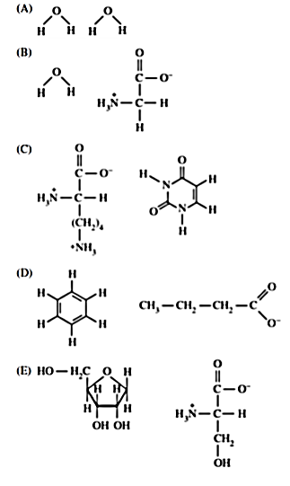

5) Which of the following best represents the backbone arrangement of two peptide bonds?

A) C_{α}—N—C_{α}—C—C_{α}—N—C_{α}—C
B) C_{α}—N—C—C—N—C_{α}
C) C—N—C_{α}—C_{α}—C—N
D) C_{α}—C—N—C_{α}—C—N
E) C_{α}—C_{α}—C—N—C_{α}—C_{α}—C

6) Given the ionization states of the amino acid cysteine, which one is the zwitterion?

7) The maximal attractive force of a van der Waals interaction occurs at which point on the following energy diagram?
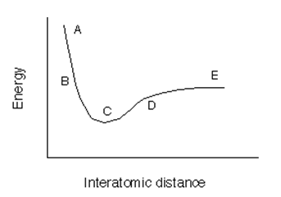
A) A
B) B
C) C
D) D
E) E

8) Which of the following statements correctly describes the structural organization of α-helices and β-sheets in proteins?

A) In α-helices, hydrogen bonds form between backbone groups of different polypeptide strands, while in β-sheets they form within one strand.
B) In α-helices, side chains alternate above and below the helical axis, while in β-sheets they project radially outward from the axis.
C) In α-helices, hydrogen bonds form between the backbone C=O of residue i and the N–H of residue i+4, while in β-sheets hydrogen bonds form between backbone groups of neighboring strands.
D) Both α-helices and β-sheets have side chains projecting into the interior, stabilizing the secondary structure through hydrophobic packing.
E) Both α-helices and β-sheets repeat every 3.6 residues, forming a helical twist stabilized by R-group hydrogen bonding.

9) A sequence of amino acids in a certain protein is found to be -Ser-Gly-Pro-Gly-. The sequence is most probably part of a(n):

A) antiparallel β sheet.
B) parallel β sheet.
C) α- helix.
D) α- sheet.
E) β-turn.

10) The weakest non-covalent interactions are:

A) ionic interactions
B) hydrogen bonds
C) hydrophobic interactions
D) van der Waals interactions
E) disulfide bonds
11) Which of the following amino acids is the most soluble in water at pH 7.0?

- Glutamate
- Tryptophan
- Leucine
- Tyrosine
- Phenylalanine

12) The Ramachandran plot for a particular protein is shown below. This protein is composed primarily of:

A) α-helices
B) parallel β-sheets
C) antiparallel β-sheets
D) a collagen-like triple helix, made of a repetitive primary sequence of glycine-proline-hydroxyproline

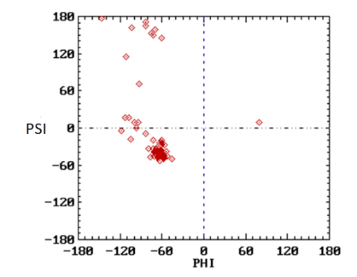

13) What would you expect about the formation of an α‐helix for a segment of a protein chain that contains lysine approximately every fourth residue with all other residues being mostly hydrophobic?

A) Helix formation would never occur regardless of pH.
B) Helix formation would be favored at high pH.
C) Helix formation would be favored at low pH.
D) Helix formation would be favored at neutral pH.
14) In the energetics of the process of transferring hydrocarbons from water to a nonpolar solvent, the factor TΔS^{SYS} is commonly:
A) Negative
B) Positive
C) Unmeasurable
D) Unimportant
E) Assumed to be zero
15) Dr. Caro needs to prepare a concentrated aqueous solution of the iron chelator DTPA (diethylenetriaminepentaacetic acid). He purchases item D6518 from Sigma-Aldrich:
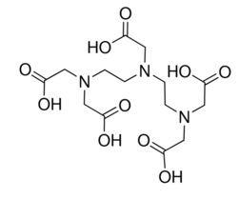
DTPA is a pentaprotic acid with pKa values of 1.8, 2.6, 4.4, 8.8, and 10.4. When Dr. Caro tries to dissolve solid DTPA in distilled water, he is unsuccessful.
What would you recommend he do to dissolve it?
A) Add a strong acid such as HCl until DTPA dissolves
B) Add a strong base such as NaOH until DTPA dissolves
C) Add a weak acid such as acetic acid until DTPA dissolves
D) Add a weak base such as NH₃ until DTPA dissolves
E) Do not use DTPA; there is no way to dissolve it in water
16) If these were in a protein in a trans configuration, which atoms would lie in a plane?

A) 2,3,4,5,6,7
B) 3,4,5,6,7,10
C) 3,4,6,7,8,10
D) 3,5,6,7,8,10
E) 3,6,7,8,9,10

17) The major bonds or interactions that stabilize the secondary structures of proteins, between atoms of the polypeptide backbone are:

A) covalent bonds
B) hydrogen bonds
C) hydrophobic interactions
D) ionic bonds
E) van der Walls interactions

18) A water-soluble globular protein is most likely to have the highest proportion of which of the following amino acid residues buried in its core?

- Histidine
- Glutamate
- Serine
- Phenylalanine
- Aspartate

19) Lactobacillus species grow optimally at low pH (5.0). To isolate them from biological samples, microbiologists often use Rogosa SL broth, which contains water, glucose, beef extract, and a buffer to maintain the acidic environment. Below is a list of possible buffers with their approximate pKa values. Which buffer would be most appropriate to use in Rogosa SL broth?

A) Acetic acid / acetate: pKa = 4.8
B) Phosphate (H₂PO₄⁻/HPO₄²⁻): pKa = 7.2
C) Tris (tris(hydroxymethyl)aminomethane): pKa = 8.1
D) Bicarbonate (H₂CO₃/HCO₃⁻): pKa = 6.3

20) Levodopa (L-dopa) is an amino acid drug that is active in relieving the symptoms of Parkinson’s disease. L-Dopa has an enantiomer, D-dopa, which has never been used because, in contrast with L-dopa, it causes deficiency of white blood cells and thus susceptibility to infections. Which of the structures shown below is levodopa?

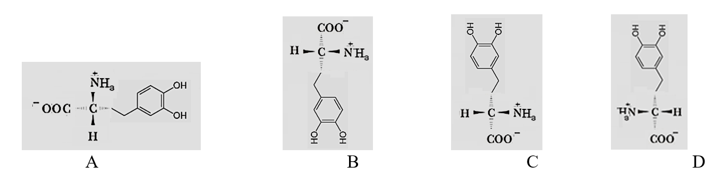

21) In a site directed mutagenesis experiment a specific Leu residue in a protein was changed to various other residues. Predict which of the following changes would have the greatest impact on the structure of the protein. (Site directed mutagenesis is a technique that specifically changes one amino acid in a protein into another amino acid)

A. Val
B. Asp
C. Ala
D. Ile
E. Phe

22) The most likely amino acid that would yield the above titration curve below is:

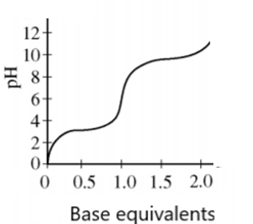

- Arginine
- Glutamic acid
- Glycine
- Histidine
- Tyrosine

23) Consider the tripeptide Glu–Lys–Ser at pH 6.0. What is the net charge?
pKa (approx.): Glu side chain 4.1; Lys side chain 10.5; N-terminus 9.0; C-terminus 2.0.

A) –2
B) –1
C) 0
D) +1
24) Which of the following best describes fibrous proteins such as collagen and keratin?
A) They are highly flexible, soluble in water, and have irregular primary sequences
B) They are rigid, insoluble in water, and have repetitive primary sequences
C) They are compact, soluble in water, and often act as enzymes
D) They are globular, flexible, and stabilized mainly by hydrophobic cores

C) Short Answers Section (20 min). 4 questions. 10 points each

1) Look at the structure of a typical alpha helix (A), and a typical antiparallel beta sheet (B):

(A) 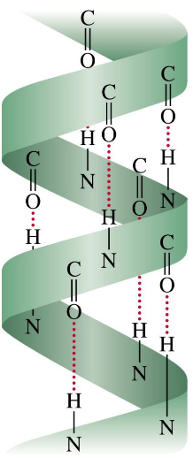 (B) 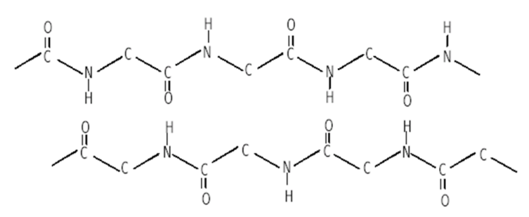
Alpha helices have a molecular dipole moment, but beta sheets do not. Explain why.

2) As a teaching assistant for a biochemistry course, you are expected to grade exams. The question that you have been assigned to grade is the following:
Draw a segment of a polypeptide chain with:
- A sidechain for tyrosine;
- φ (phi)=180° and ψ (psi)=0°;
- Circles on bonds about which there is no rotation;
- Arrows indicating the bonds about which φ and ψ rotational angles are measured.

One student gives the following answer:

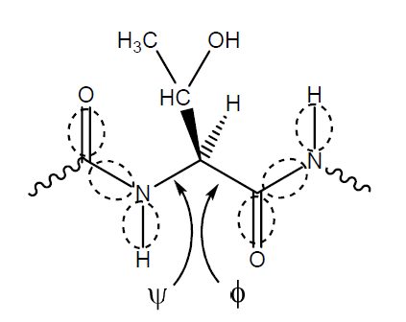
What is wrong with this drawing? Briefly list all the errors you find in the student’s answer, giving one error per line.

3) Sketch the titration curve for the tripeptide Val–Lys–Ser.
- Label the x-axis as “OH⁻ equivalents added”. Clearly mark the first, second, and third equivalence points as 1, 2, and 3.
- Indicate the corresponding half-equivalence points (0.5, 1.5, 2.5).
- Label the y-axis as “pH”.
- Mark on the y-axis the approximate pKa values at their half-equivalence points
- Circle on the curve the buffering regions.
- Mark on the y-axis the isoelectric point (pI) of the tripeptide.
4) Fill the boxes below:

Structure at pH 7.0 Three letter code Classification

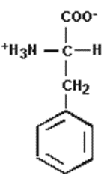

SER

Amino acid | α-COOH pK_{a} | α-NH₃⁺ pK_{a} | R-group pK_{a}
Gly | 2.3 | 9.6 | -
Ala | 2.4 | 9.7 | -
Val | 2.3 | 9.6 | -
Leu | 2.4 | 9.6 | -
Iso | 2.4 | 9.7 | -
Met | 2.4 | 9.2 | -
Pro | 2.1 | 10.6 | -
Phe | 1.8 | 9.1 | -
Trp | 2.4 | 9.4 | -
Ser | 2.2 | 9.2 | -
Thr | 2.6 | 10.4 | -
Tyr | 2.2 | 9.1 | 10.1
Cys | 1.7 | 10.8 | 8.3
Asn | 2.0 | 8.8 | -
Gln | 2.2 | 9.1 | -
Asp | 2.1 | 9.8 | 3.9
Glu | 2.2 | 8.8 | 4.3
Lys | 2.2 | 9.0 | 10.5
Arg | 2.2 | 9.0 | 12.5
His | 2.4 | 9.2 | 6.0

